**Project Planning Phase Milestones and Tasks**

|  |  |
| --- | --- |
| Date | 26 October 2022 |
| Team ID | PNT2022TMID48851 |
| Project Name | Real time river water monitering and Control system |
| Maximum Marks | 8 Marks |

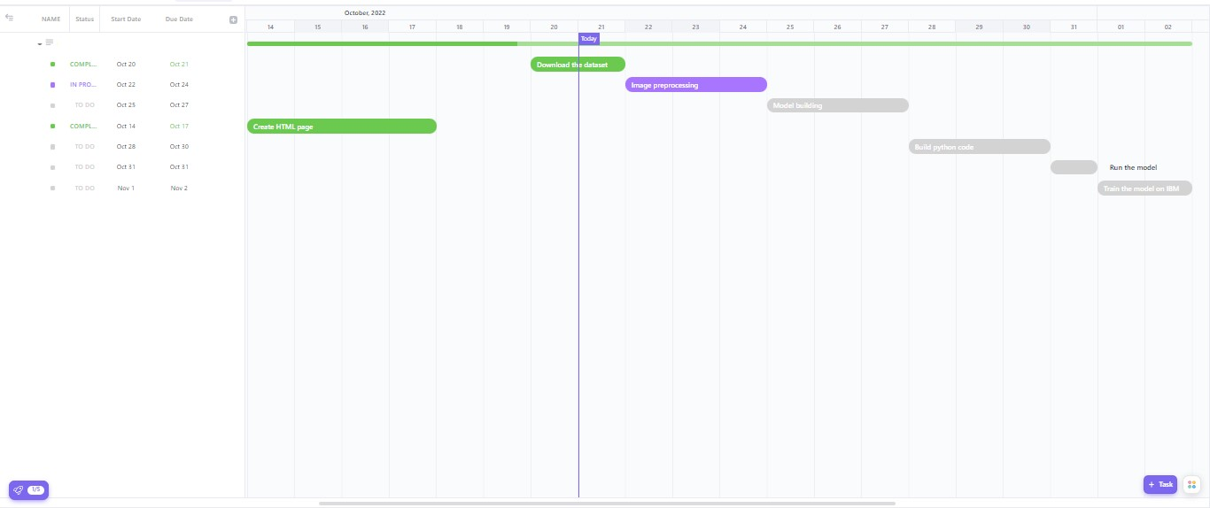

Link for the above milestone :https://app.clickup.com/43289481/v/li/205283671